***Korean style scarf***

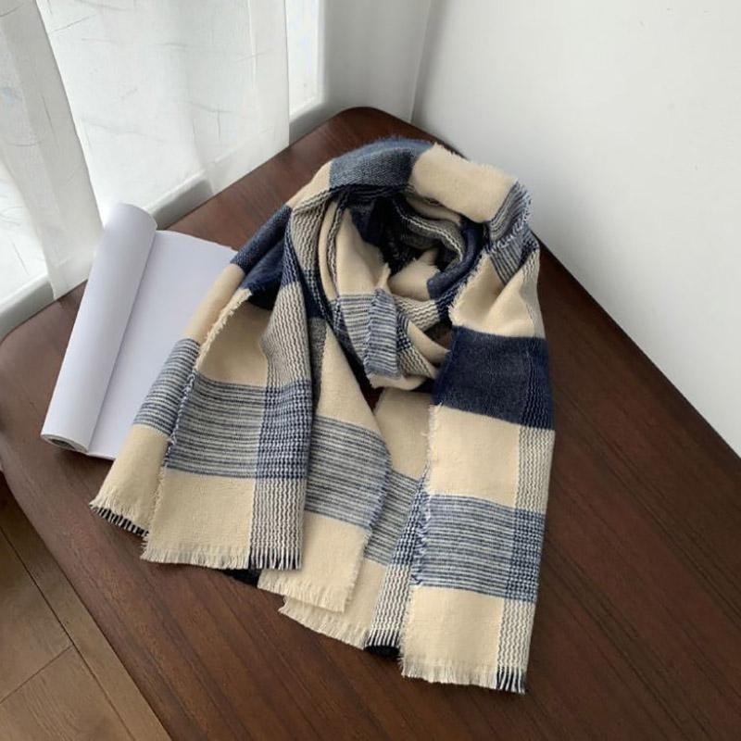

*Korean style scarf with simple but delicate black and white plaid pattern.  
- Super soft fashion wool scarf.  
-Designed with new and fresh tones, bringing a difference to the girls' wardrobe, easy to coordinate, suitable for cold winter days, bringing a feeling of both warmth and comfort. The shawl is light but still exudes elegance.*